|  |
| --- |
| **Team ID :** LTVIP2025TMID32402 |
| Project Name : Enchanted Wings: Marvels of Butterfly Species |

**Project Structure**

Create the Project folder which contains files as shown below

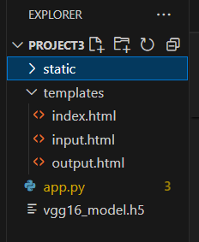

* We are building a Flask application with HTML pages stored in the templates folder and a Python script app.py for scripting.
* Vgg16_model.h5 is our saved model. Further, we will use this model for flask integration.

<!DOCTYPE html>

<html lang="en">

<head>

<meta charset="UTF-8">

<title>Butterfly Species Identifier</title>

<style>

body {

font-family: Arial, sans-serif;

background: #f0f8ff;

text-align: center;

padding: 50px;

}

.upload-box {

background-color: #fff;

padding: 20px;

border-radius: 10px;

display: inline-block;

box-shadow: 0px 0px 10px #ccc;

}

.result {

margin-top: 20px;

font-size: 20px;

color: #007BFF;

}

</style>

</head>

<body>

<h1>🦋 Enchanted Wings: Butterfly Classifier</h1>

<div class="upload-box">

<form method="POST" action="/" enctype="multipart/form-data">

<input type="file" name="image" accept="image/*" required><br><br>

<input type="submit" value="Classify Butterfly">

</form>

{% if prediction %}

<div class="result">

<strong>Prediction:</strong> {{ prediction }}

</div>

{% endif %}

</div>

</body>

</html>

**Features:**

* Simple and responsive layout
* Image upload form
* Displays prediction result returned by the Flask backend

**Project Structure**

Create the Project folder which contains files as shown below:

* Project_Folder/
  + ├── templates/
  + │ └── index.html
  + ├── static/
  + │ └── (optional static assets: CSS, JS, images)
  + ├── app.py
  + ├── Vgg16_model.h5
  + └── (other helper files if needed)